Assignment

Submitted By: Arslan Ahmad
Batch: B-III Artificial Intelligence (Evening).
Institution: Tech Hub



Commands:
The following commands will be executed in the Ubuntu operating system.

1. chmod command:
chmode is basically used to control the access and the security to read, make any changes or execute a files folders or directory in Ubuntu. It helps us to manage the access and security file in the system.
Command Structure:
chmod a+rwx file.txt.
where,
a means all users are allowed to read write and execute in file.txt.
r means that user is allowed to read,
w mean user can write,
x mean user can execute permissions.
Command Output:
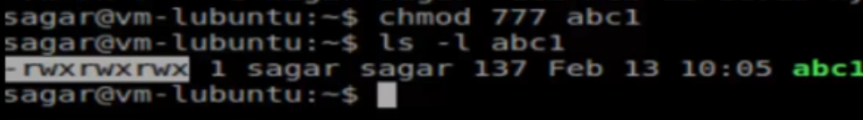

2. ps command:
The ps command is used in ubuntu to display the essential information about the running processes. It is usually used in monitoring and management of the running processes.

Command Structure:
ps -aux file.txt.

where,
ps shows the running processes.
-a shows processes of all users.
-u is used in detailed display of user information.
-x shows processes which are not attached to terminal.

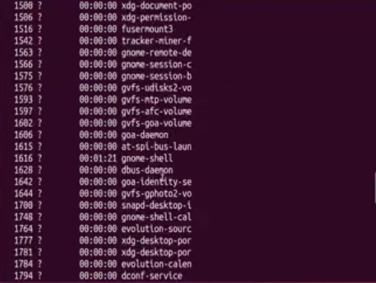
Command Output:

3. kill id command:
Kill id command is applied to stop or terminate the process which is running.

Command structure:
Kill (PID).
Where,
PID is the process id of the process you want to stop.

Command Output:
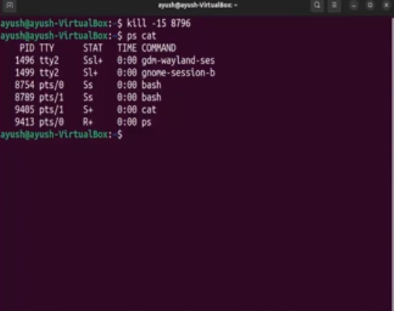

4. sudo apt update command:
This command refreshes the list of packages available in Ubuntu from the software repositories. It checks out the latest versions of the software that are available and update the information about them, ensuring that your system knows which packages can be installed or modified.
Command structure:
sudo apt update.

Command Output:
